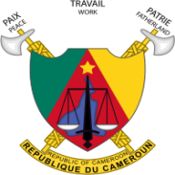



4th and final African Preparatory Meeting for the 2023 World Radiocommunication Conference (APM23-4)
Yaoundé from 7 to 11 August 2023 preceded by the
8th Sub Sahara Spectrum Management Conference ‘Spectrum Africa 2023’
Yaounde from 3 to 4 August 2023

Practical information for participants

Venue of Events
Africa Spectrum 2023 and APM23-4 will take place respectively from 3 to 4 August 2023 and from 7 to 11 August 2023, at the Yaoundé Conference Centre, located at the address below:

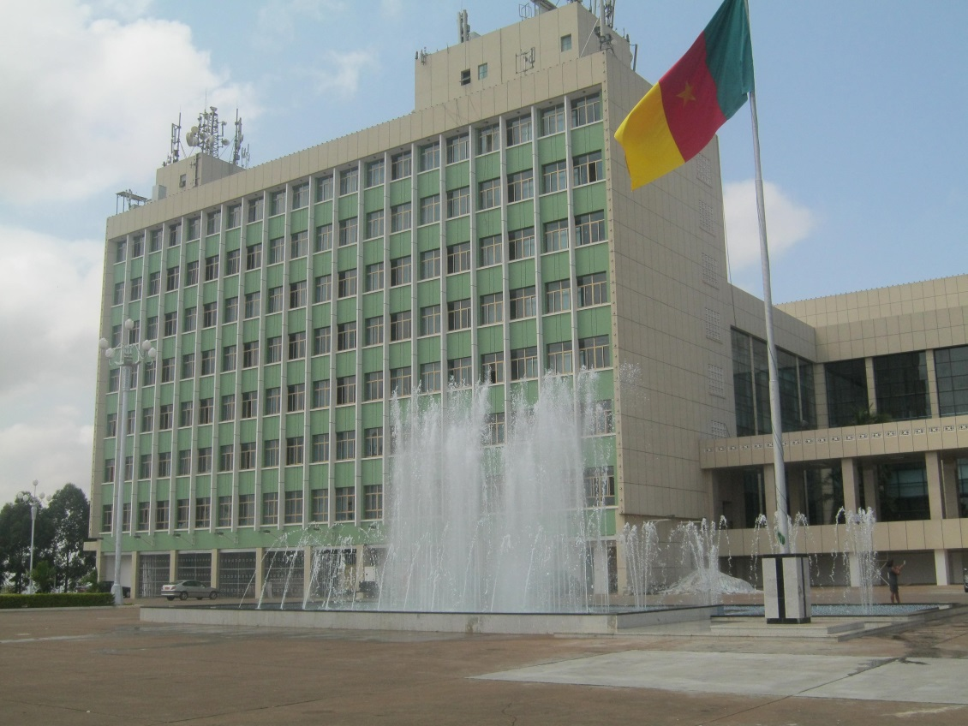

Working Hours

Participants may register by submitting the registration form (annex to this document) duly completed before 30 July 2023 to itu-yaounde@itu.int / ottou@minpostel.gov (valery_hottou@yahoo.fr) / a.koech@atuuat.africa and will collect their badges at the meeting venue on 3 August and 7 August 2023 from 8 am onwards.

Hotel Reservations
Participants are advised to book hotel accommodation by telephone or e-mail, directly with the various hotels of their choice (ranging from 3 to 5 stars), by providing a copy to the contact persons of the organising committee (see contact below). We would like to inform the participants that a transportation service from the airport to the various hotels and from the hotels to the meeting venue will only be provided for delegates who must have booked in one of the officially recommended hotels.

Presentation of Yaounde
The ‘City of Seven Hills’ is the political capital of Cameroon. With over 2.8 million inhabitants in 2018, Yaounde is the second most populated city in the Central African country after Douala.
Yaounde is the capital of the Mfoundi Division in the Centre Region and is home to the most important institutions of Cameroon. The local inhabitant has nicknamed the city ‘Ongola or Ngola’, which comes from the former name of the capital of Cameroon, Ongola, which means ‘fence’ in the Ewondo language and referred to the wall of the former German post3.
Located at an altitude of 750 metres, the city of Yaoundé has the following geographical coordinates: latitude: 3 ° 52’ 12 North and longitude: 11 ° 31’ 12 East.
In February 1888, a first German team led by Lieutenants Kund and Tappenbeck came to Cameroon. On their way south to Nachtigal from Grand-Batanga, they came upon people planting groundnut in this hilly area, so they asked them where they were from. The farmers replied that they were Mia Wondo, those who plant groundnut, an expression that the Germans perceived and translated as Jaundo or Jaunde 6 (Yaoundé). This explanation about the origin of the city’s name is, despite its popularity, not proven, as Kund and Tappenbeck made a distinction between the landscape or country ‘Jaunde’ and the post, which they called ‘Jeundo’. It was not until the time of Georg August Zenker (December 1889 - May 1895) that the name ‘Jaunde’ became common in German colonial administrative texts.

List of Recommended Hotels
Hilton Hotel * * * * *
Standard Room: CFA F 150,000
Deluxe Room: CFA F 238,500
Standard Executive Room: CFA F 254,000
Deluxe Executive Room: CFA F 285,000
Junior Suite: CFA F 397,000
Executive Suite: CFA F 417,375
Presidential Suite: CFA F 1,080,000

Rates include breakfast and tourist tax
Travel time to the venue of events: 15 minutes

Free shuttle service available between Yaoundé Nsimalen airport and the hotel. Kindly make a request by providing your arrival and departure time.

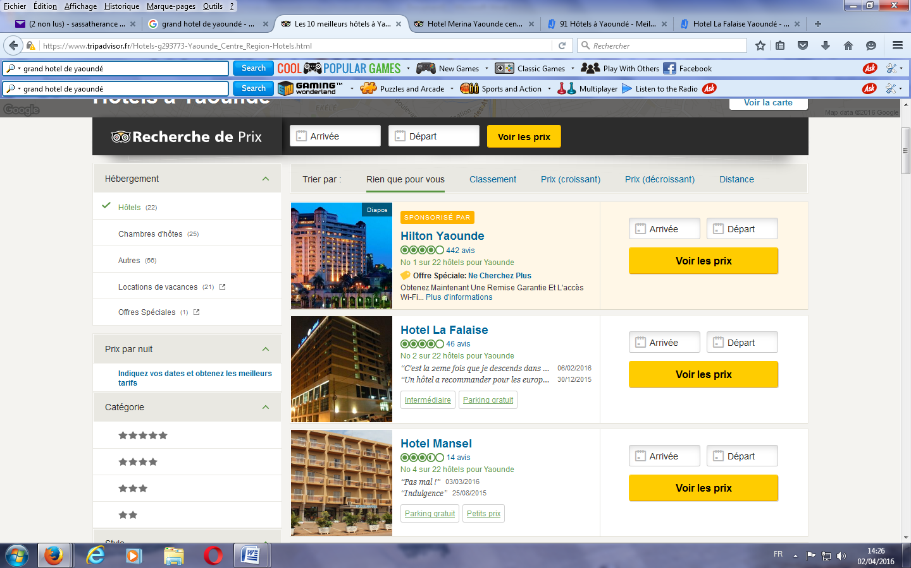

Tel: +237 222 23 36 36 www.hilton.com E-mail: reservation.yaounde@hilton.com

Hotel Mont Fébé * * * *
Standard Room: CFA F 50,000
Executive Room: CFA F 76,000
Junior Suite: CFA F 100,000
Senior Suite: CFA F 150,000

Rates include breakfast and tourist tax
Travel time to the venue of events: 5 minutes

Free shuttle service available between Yaoundé Nsimalen airport and the hotel. Kindly make a request by providing your arrival and departure time
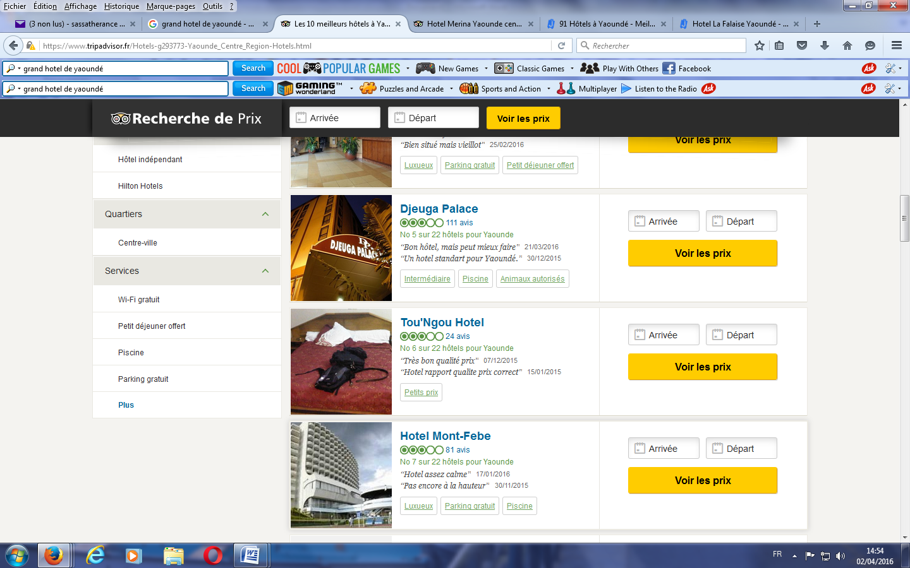

Tel: +237 222 21 40 02 www.hotel-montfebe.com E-mail: reservation@hotel-montfebe.com

Djeuga Palace Hotel * * * *
Travel time to the venue of events: 15 minutes

Shuttle service available between Yaoundé Nsimalen airport and the hotel.
Standard Room: CFA F 75,000
Superior Room: CFA F 80,000
Executive Room: CFA F 95,000
Suite Palace: CFA F 200,000

Rates include breakfast and tourist tax

Tel: +237 222 22 46 46 www.djeuga.com E-mail: reservation@djeuga.com

Hôtel La Falaise * * * *
Travel time to the venue of events: 15 minutes

Shuttle service available between Yaoundé Nsimalen airport and the hotel.

Standard Room: CFA F 84,000
Superior Room: CFA F 94,000
Suite: CFA F 119,000

Rates include breakfast and tourist tax

Tel: +237 222 22 06 16 www.lafalaisehotels.com E-mail: reservations@lafalaisehotels.com

Star Land Hotel * * * *
Executive Plus Room: CFA F 84,000
Premium Room: CFA F 94,000
Executive Twin Room: CFA F 145,000
Deluxe Room: CFA F 130,000

Rates include breakfast and tourist tax
Travel time to the venue of events: 10 minutes

Shuttle service available between Yaoundé Nsimalen airport and the hotel.

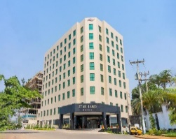

Tel: +237 671 00 08 88 www.starlandhotel.com Email: commercialyaounde2@starlandhotel.com

Suita Hotel * * * *
Travel time to the venue of events: 8 minutes

Shuttle service available between Yaoundé Nsimalen airport and the hotel.

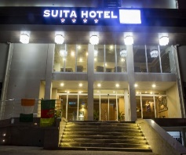
Suite 1 Room : CFA F 95,000
Suite 2 Rooms : CFA F 140,000

Rates include breakfast and tourist tax

Tel: +237 658 84 84 84 www.suita-hotel.com Email : contact@suita-hotel.com

UNITED HOTEL INTERNATIONAL * * * *
Travel time to the venue of events: 10 minutes

Shuttle service available between Yaoundé Nsimalen airport and the hotel.

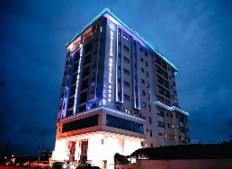
Comfort Room: CFA F 98,000
Twin Room : CFA F 115,000
Twin Plus Room: CFA F 125,000
Comfort Plus Room: CFA F 125,000
Deluxe Comfort Plus Room: CFA F 140,000
Junior Suite: CFA F 150,000
Exclusive Suite : CFA F 175,000
King Suite : CFA F 200, 000

Rates include breakfast and tourist tax

Tel : +237 680 96 80 96 / 690 95 01 73 www.unitedhotelsgroup.com E-mail : reservations@unitedhotelinternational.com

Boun’s Hotel * * * *
Travel time to the venue of events: 10 minutes

Shuttle service available between Yaoundé Nsimalen airport and the hotel.
Standard Classical Room: CFA F 79,000
King size bed Room: CFA F 84,000
Standard Plus Room: CFA F 89,000
Comfort Room: CFA F 99,000
Standard Twin Room: CFA F 140,000

Rates include breakfast and tourist tax

Tel: +237 657 103 879 / 696 31 56 38 www.bounshotel.com E-mail: commercial@bounshotels.com
Hotel Franco * * * *
Travel time to the venue of events: 10 minutes

Shuttle service available between Yaoundé Nsimalen airport and the hotel.
Standard Room: CFA F 55,000
Deluxe Room: CFA F 75,000
Suite: CFA F 150,000

Rates include breakfast and tourist tax
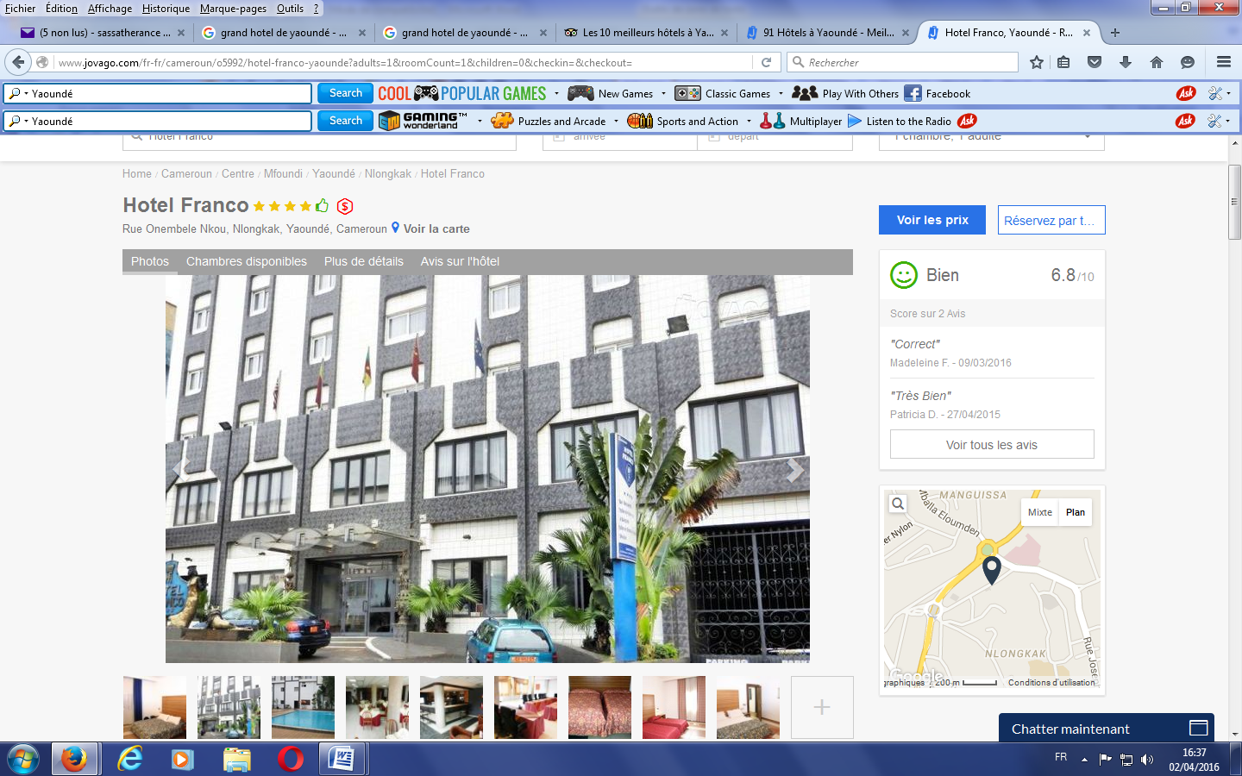

Tel: +237 222 20 13 07 www.hotelfranco.cm E-mail: hotelfranco@gmail.com
Hôtel AZUR * * *
Travel time to the venue of events: 5 minutes

Shuttle service available between Yaoundé Nsimalen airport and the hotel.

Junior Room: CFA F 30,000
Senior Room: CFA F 45,000
Double Room: CFA F 52,000
Suite: CFA F 100,000

Rates include breakfast and tourist tax

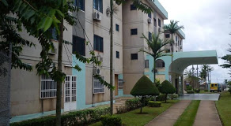

Tel: +237 656 15 49 61/654 97 72 69 E-mail: hotafric2001@yahoo.fr
MEUMI PALACE * * *
Travel time to the venue of events: 10 minutes

Shuttle service available between Yaoundé Nsimalen airport and the hotel.

Single Room: CFA F 35,000
1 Bedroom 1 Living Room Apartment: CFA F 45,000
2 Bedrooms 1 Living Room apartment: CFA F 55,000
3 Bedrooms 1 Living Room apartment: CFA F 70,000
Junior Suite: CFA F 75,000
Senior Suite: CFA F 85,000
Prestige Suite: CFA F 75,000

Rates include breakfast and tourist tax

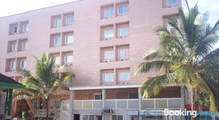

Tel: +237 694 02 01 65 / 699 68 88 32 www.leshotelsmeumi.com E-mail: meumipalace@yahoo.fr
HÔTEL DES DÉPUTÉS* * *
Room overlooking the lake: CFA F 45,000
Room overlooking the parking: CFA F 40,000
Senior Suite: CFA F 96,000

Rates include breakfast and tourist tax

The room rate includes tourist tax.

Travel time to the venue of events: 10 minutes

No shuttle service available between Yaoundé Nsimalen airport and the hotel.

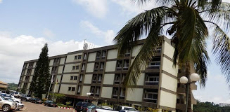

Tel: +237 698 00 90 30 / 679 52 86 36 www.hoteldesdeputes.cm E-mail: hotel.deputes@yahoo.fr
Congress Hotel * *
Travel time to the venue of events: 05 minutes

No shuttle available.

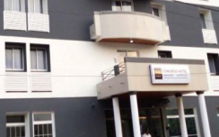
Standard Room: CFA F 40,000
Comfort Room: CFA F 45,000
Deluxe Room: CFA F 56,000
Junior Suite: CFA F 71,000

Rates include breakfast and tourist tax

Tel : +237 242 18 00 50 / 683 89 52 92 E-mail : contact.chyc@gmail.com

Procedure for Obtaining Visas

The Government has just aligned the consular system with international standards in order to make Cameroon a more attractive destination and to respond to the complaints of the Cameroonian diaspora.

Since 30 April 2023, with the introduction of the E-visa system, for entry visas to Cameroon shall be done exclusively online, by accessing: www.evisacam.cm.

In this regard, the Minister of External Relations hereby invites any applicant to kindly login to the dedicated website in order to be issued an electronic visa by following the 4 steps below:
1 – Online pre-enrolment by the applicant, by creating a user account in the platform, filling out the online form and validating it, after which a notification of confirmation shall be sent to the applicant by SMS or email;
2 – Online payment of requisite fees, using various payment options (MasterCard, Visa, PayPal, Mobile Money, Orange Money, Moov, Wave, Safaricom, Airtel, Vodacom, Africell). The applicant receives a notification of proof of payment by email or SMS;
3 – Processing of the Application. This shall be done by the competent Diplomatic Mission or Consular Office or the closest one, geographically. For applicants in areas far-flung from Diplomatic Missions or those not covered by a Mission, an online visa issuance authorisation, together with a QR Code, shall round off this phase. For those residing in cities with a competent Diplomatic Mission, a notification shall be sent to them via email or SMS, scheduling an appointment to proceed with the biometric enrolment. Either procedure shall be completed within 72 hours from the date of pre-enrolment. This deadline shall be reduced to 24 hours in the case of express visa applications.
4 – Affixing of the visa sticker. It is done either at the entry Border Post for holders of the online visa issuance authorisation, or at the competent Diplomatic Mission or Consular Post for applicants having completed their biometric enrolment at the said Mission or Consular Post. This phase culminates in the affixing of the visa sticker on the applicant’s passport or travel document.

Telephone Operators
The delegates can subscribe a service pack with mobile telephone operators. A valid passport is the prior document for subscriptions. The costs of this operation vary depending on the operator and desired pack. The 3G/4G services are available.

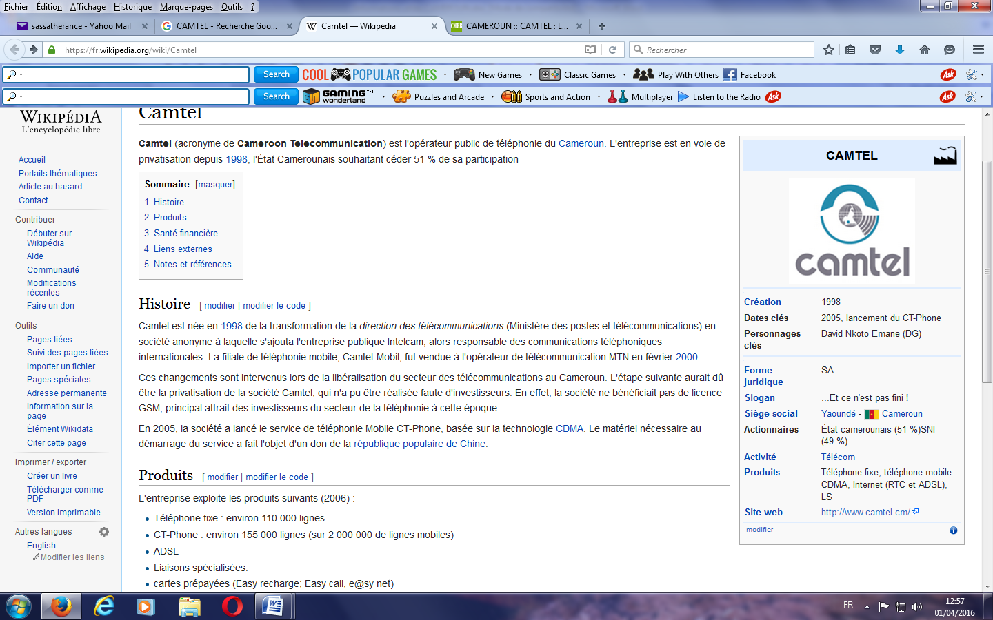
Camtel: Cameroon Telecommunications is the
Cameroon Public Telephone Operator .

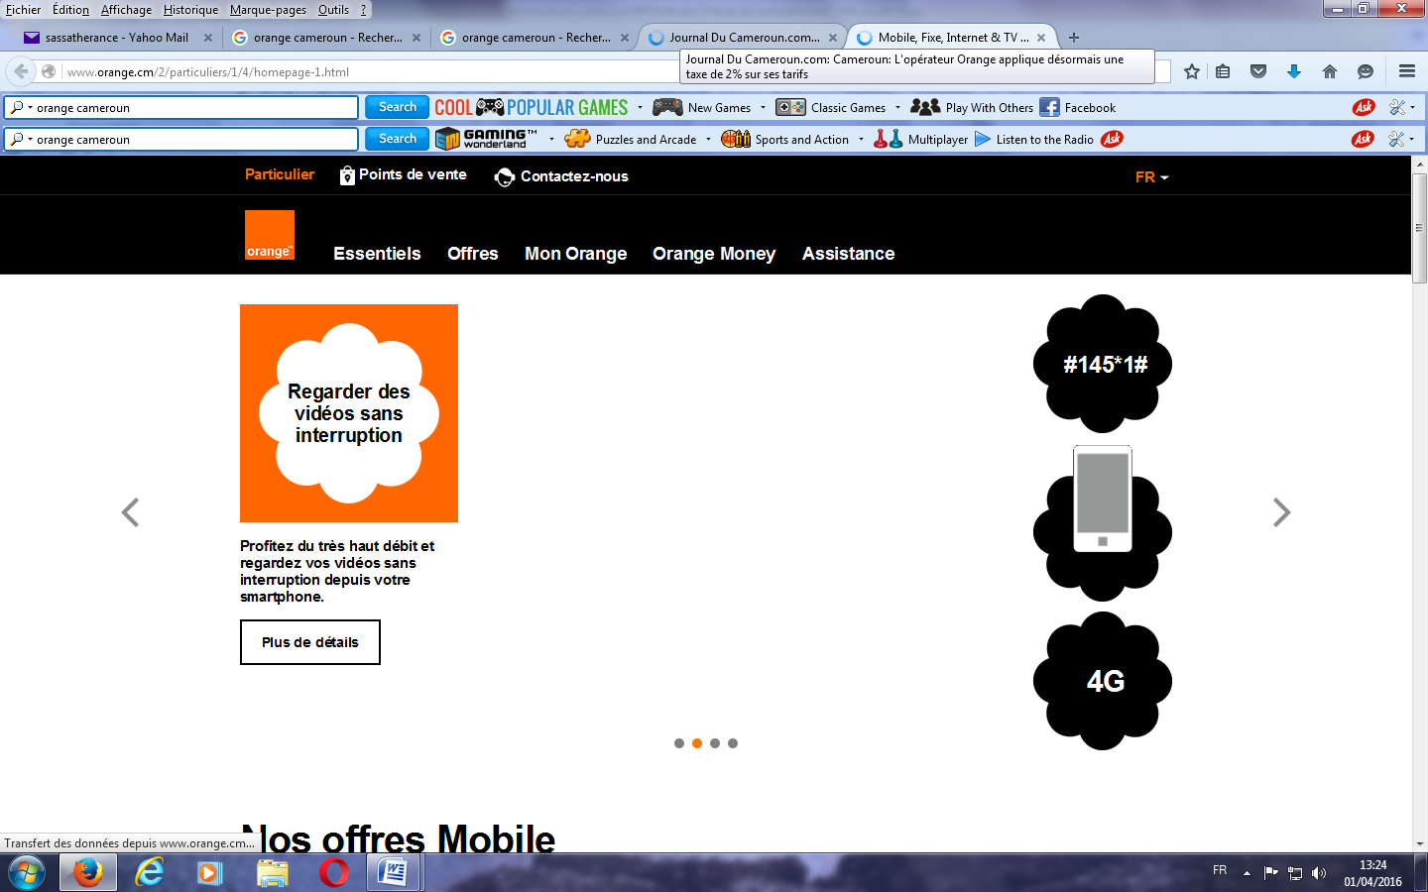
Orange Cameroun: Subsidiary of the French multinational company Orange

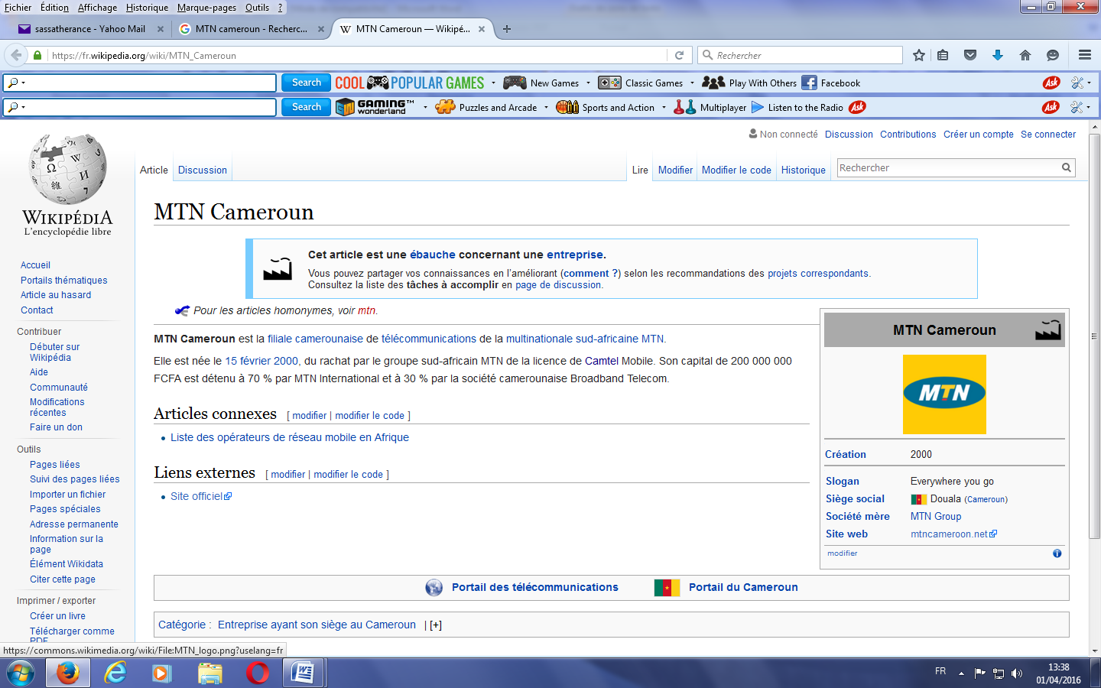
MTN Cameroon: Subsidiary of the MTN

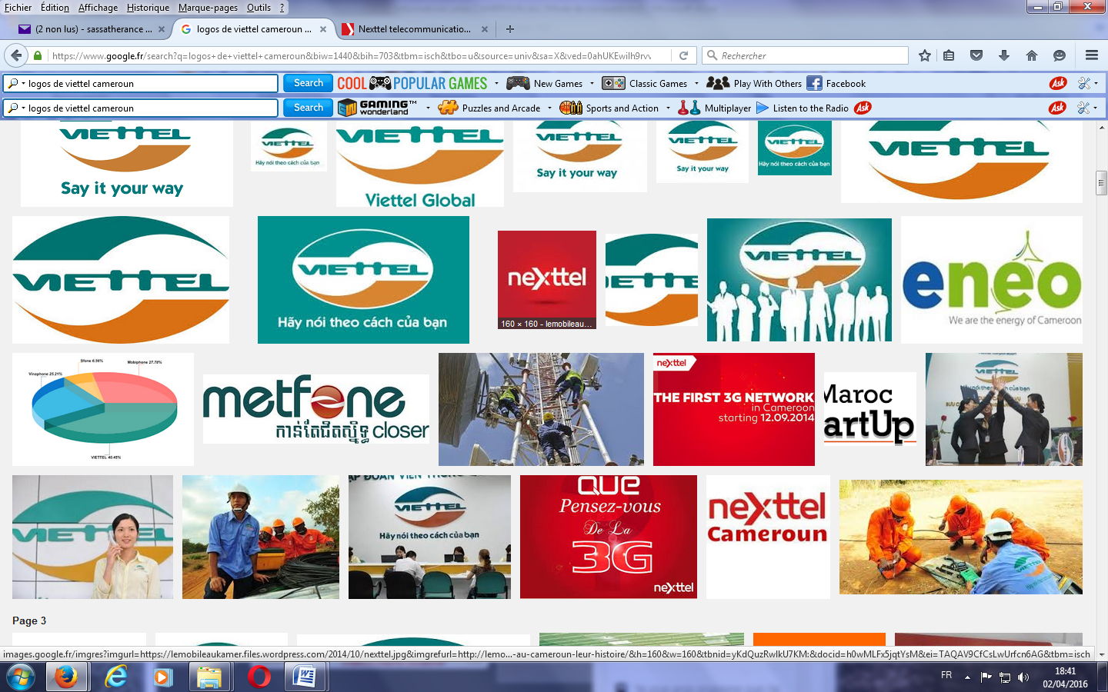

VIETTEL Cameroun: also known as NEXTTEL

Transportation of Participants

The transport of participants will be provided at arrival and departure to the airport, as well as from recommended hotels to the venue of the meeting and vice-versa. Please note that any delegate/participant residing out of the recommended hotels will personally take care of his/her transportation from the hotel of residence to the venue of the meeting and vice-versa.

Various vehicles are provided for lease in the international airports and down town (Yaoundé
and Douala). Taxi fees are also available at variable rates according to the following cases:

- At day (from 5 am in the morning to 10 pm in the evening): if you are alone on-board (hired drop: CFA F 3,000, taxi on hire: CFA F 3,500/hour) or dropping together with other passengers (CFA F 300);
- At night (from 10 pm in the evening to 5 am in the morning): if you are alone on-board (hired drop: CFA F 3,500, taxi on hire: CFA F 4,000/hour) or dropping together with other passengers (CFA F 350);
- Daily rentals: over-the-counter negotiation.

Currency
Commercial transactions are done solely in CFA francs. The foreign currencies that are easily convertible into CFA francs are the dollar (US$) and Euro (€). Credit cards (Visa, Master Card) are also accepted in some hotels.

1 Euro = 655.957 XAF
1 USD = 611.93872 XAF on 6 June 2023

Climate

In Yaoundé, it is very difficult to predict the weather at a given time and place.

However, according to weather forecasts, the first half of August is very hot with temperatures ranging from 20°C to 27°C at midday.

It is important to drink plenty of water and stay in the shade.

You can expect rain for about the second half (8-15 days) of August in Yaoundé.

Don't forget your rain gear!
Given the climatic uncertainties, these averages may be contrasted.

Security

Yaoundé is a city where large conferences are usually held and has a low level of insecurity for travellers. However, just like in any major city, it is important to take precautions for your personal safety and use your common sense all the time.

Therefore, delegates should exercise common sense when it comes to safety precautions and not venture outside the commercial and tourist areas without a trustworthy local guide

In the event of security incidents, the visitors must call the police at 117 and 1500, and the Gendarmerie at 113. The fire-fighters can be contacted at 118

A security post will be installed at the site of events.

Prohibitions

- No prohibition.

Electricity

The power/voltage of the alternative current in Cameroon is 220V, with a frequency of 50 Hz. The majority of electric sockets are of the format below with two entries.

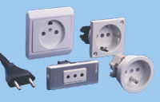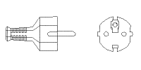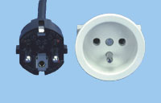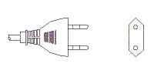

Services available for Participants during the Event

Venue of meetings:

A free Internet access will be available in the meeting rooms of the Conference Centre.

Medical assistance:

Mild climate, good health situation, controlled levels of hygiene, there is no special risk of contracting diseases. Hospital infrastructure is modern and there are efficient medical possibilities.

Flight, Health and Insurance

- Flights

Some teams will be deployed at the Yaoundé Nsimalen and Douala international airports to welcome the delegates.

Kindly note that the final destinations are the Yaoundé NSIMALEN International Airport (NSI) located at 18 kilometres from the city of Yaoundé. Passengers that would come from Douala (located at 250 km from Yaoundé) should inform the contact persons for the purpose of facilitating their reception.

Every day, the national air company Camair-Co services the cities of Yaoundé and Douala The flight programme can be consulted on the link below: http://www.camair-co.cm/CM/fr/horaireVols

- Health

When boarding a flight to Cameroon, you will be required to submit:
- An international vaccination booklet with proof of vaccination against yellow fever;
- A COVID-19 vaccination record or a negative COVID-19 PCR test result lasting no more than 48 hours.

All incoming travellers are subject to a compulsory RDT test.

During your stay in Cameroon as part of these events, a health cover system will be put in place to ensure that any illnesses that may arise are taken care of.

A health post will be set up at the Conference Centre, where the events will take place, and a mobile team will be deployed to ensure the transfer to hospitals of cases of illness requiring in-depth treatment.

The telephone numbers of some health officials will be given to you for rapid contact, if necessary services or health care.

To leave Cameroon, a COVID-19 vaccination booklet is required on arrival at border health posts. The presentation of a COVID-19 test, PCR or RDT, depends on the requirements of the country of the final destination.

A team from the Ministry of Public Health will be available on-site during your stay to help you if you need any COVID-19 tests or vaccines.

- Insurance

The delegates are personally responsible for their insurance, in the event of personal injury, of medical emergency and loss of luggage and currencies.

General Information

Head of State | H.E. Paul BIYA
Prime Minister | Mr Joseph DION NGUTE
Minister of Posts and Telecommunications | Mrs Minette LIBOM LI LIKENG
Surface area | 475,000 km²
Population | 28 million
Political capital | Yaoundé
Economical capital | Douala
Main cities | Bafoussam, Bamenda, Buea, Bertoua, Ebolowa, Garoua, Ngaoundéré, Maroua, Limbé, Sangmélima
Official languages | French and English
Phone code | +237
TLD Internet | .cm
Time Zone | GMT+1

CONTACT PERSONS

- REPRESENTATIVE OF THE ITU AREA OFFICE FOR CENTRAL AFRICA AND MADAGASCAR

Jean Jacques MASSIMA LANDJI
Tel : +237 222 22 92 91 /92
E-mail: itu-yaounde@itu.int

- AFRICAN TELECOMMUNICATIONS UNION

Kezias Kazuba MWALE
Tel : +254 736 58 66 66
E-mail: k.mwale@atuuat.africa

Alice Koech
Tel : +254 722 51 00 12
E-mail: a.koech@atuuat.africa

- MINISTRY OF POSTS AND TELECOMMUNICATIONS

OTTOU Valéry Hilaire
Tel: +237 693 06 63 83
E-mail: ottou@minpostel.gov.cm / valery_hottou@yahoo.fr

- Forum Europe | Forum Global

DAN CRAFT
Tel: +44 7748 960955
E-mail : dan.craft@forum-europe.com

KATE Lymer
Tel: +237 242 10 09 17 / 696 92 53 37
E-mail: kate.lymer@forum-europe.com

We wish a hearty welcome to all delegates and a pleasant stay in Cameroon, Africa in miniature.

