25th ORDINARY SESSION OF THE ADMINISTRATIVE COUNCIL (AC) OF THE AFRICAN TELECOMMUNICATIONS UNION (ATU)

KINSHASA, DEMOCRATIC REPUBLIC OF CONGO FROM 08 TO 10 JULY 2024

PRACTICAL INFORMATION ABOUT THE EVENT

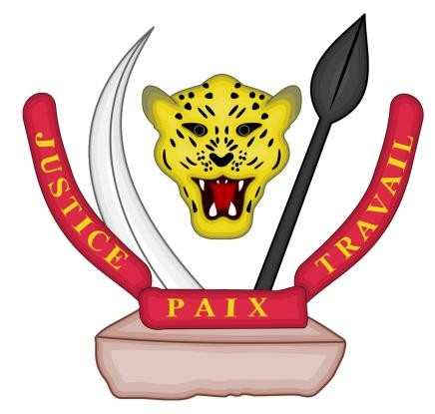National Flag 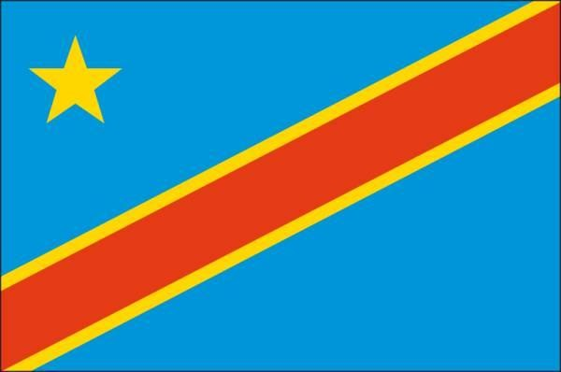
Emblem

VENUE

KIN PLAZZA ARJAAN ROTANA
1, Avenue de l’Ouganda, Kinshasa Gombe Web Site: www.rotana.com.

GEOGRAPHIC LOCATION

The Democratic Republic of Congo is a country in Central Africa, which stretches from the Atlantic Ocean to the Eastern plateaux and lakes, and covers most of the Congo Basin. It is four times the size of France and eighty times the size of Belgium. The 11th-largest state in the world having an area of 2,345,409 km², the country shares its borders with nine neighbouring countries, including: Angola to the South-West, the Republic of Congo to the West, the Central African Republic to the North, South Sudan and Uganda to the North-East, Rwanda and Burundi to the East, and Tanzania and Zambia to the South-East.

The Democratic Republic of Congo is a highly decentralised unitary State. Due to its geographical position, it is a member of the Economic Community of Central African States (ECCAS), the Economic Community of Southern African States (COMESA), the Economic Community of the Great Lakes Countries (CEPGL) and the East African Community (EAC). Its population is estimated at 105,044,646 inhabitants.

The capital Kinshasa covers an area of 9,965 square kilometres, with a population estimated at 17 million in its metropolitan area in 2021. It is the third most populous city in Africa after Cairo and Lagos, and the largest French-speaking community in the world.

CLIMATE

The country, which is located astride the Equator, has a warm equatorial climate in the Centre, and tropical towards the North and South. Climate change happening in the country determines very diverse ecosystems and highly rich biodiversity.

Half of the territory, which covers the central basin is made up of forests. The other half lying close to the tropics is dominated by savannahs (plateaus and high plateaus).

The soils of the DRC are predominantly equatorial, tropical and azonal, comprising vast tracts of unused arable land with very favourable climatic conditions. The climates and vegetation determine four distinct zones: an equatorial zone in the central basin with high temperatures and rainfall (between 23 and 26 °C and 1,765 mm of precipitation in Kisangani, over 2,000 mm in the lower Tshuapa Valley, and dense forest; two tropical zones suitable for wooded savannah on either side of the fourth north and south parallels (between 16 ° and 22 °C and 1,200 mm in Lubumbashi. This natural configuration provides the following benefits: to the East, there is a rich basaltic soil suitable for agriculture. In the South-East, the savannah lands alternating with numerous gallery forests which represent a dense hydrographic network. There is a layered vegetation in the Eastern mountains, from tropical forest to high-altitude grasslands.

In Kinshasa, the climate is hot and rainy from October to May, pleasant from May to September. In July, the average temperature is 20 °C.

TOURISM

The Democratic Republic of Congo has particularities in terms of relief, climate, fauna and flora which allow it to develop various types of tourism throughout the year, including beach tourism, mountain tourism, congress and business tourism, safari and hunting tourism, ecotourism, and cultural tourism.

FLIGHTS AND ENTRY VISA

  - Flights

Kindly note that the final destination is the Ndjili International Airport located at approximately 27 kilometres from the City-Province of Kinshasa. The following international airlines fly to Ndjili International Airport:

- Kenya Airways
- Ethiopian Airlines
- Turkish Airlines
- Bruxelles Airlines
- Air France
- South Africa Airways
- Ouganda Air

Nd’jili Airport is an international airport (1 hour 20 by car to the city centre). A dedicated staff will be deployed at Nd’jili International Airport to welcome delegates.

Entry visa to the Democratic Republic of Congo

- List of African countries exempt from an entry visa to the Democratic Republic of Congo:

  - Countries of the Economic Community of the Great Lakes Region (CEPGL): Rwanda and Burundi
  - Countries of SADC (South Africa, Botswana, Lesotho, Madagascar, Malawi, Mauritius, Mozambique, Namibia, Tanzania, Zambia, Angola, Swaziland, Seychelles, and Zimbabwe)
  - Benin
  - Senegal
  - United Arab Emirates: Visa exemption only for officials;
  - Turkey: only diplomatic passport holders are exempt from entry visas.

List of African countries with which the DRC has signed agreements to issue flying visas (airport visas)

Transit visas are issued in situations when nationals of countries without diplomatic representatives apply for visas. Therefore, for nationals of African countries where the Democratic Republic of Congo does not have diplomatic representations; they can refer to their Minister of Foreign Affairs so that the latter may write to the competent authorities of the DRC to facilitate their travel by granting them flying visas.

Any departure from the DRC is subject to a payment of 55 USD (Gopass) payable at the airport.

There are no specific agreements, but rather principles that apply to facilitate movement of people wishing to travel.

Therefore, it is important that the Minister of Foreign Affairs inform our African diplomatic missions through a multiple message about the 25th session of ATU Administrative Council of in Kinshasa (DRC), so as to facilitate participants’ travel arrangements and enable them to attend the meeting.

- Visa application forms can be downloaded from the website. www.evisa.gouv.cd

Given that ATU’s headquarters are hosted in Nairobi, Kenya, pending its relocation to Kinshasa. Our embassy will be instructed to act as an interface between the Government and ATU.

TRANSPORT

Transport will be provided on arrival and departure. In addition, buses will run between the hotels on the recommended list and Kin PLAZZA ARJAAN ROTANA.

In addition, transport will be provided for socio-cultural events organised for delegates.

ACCOMMODATION

  - Reservations
For your hotel reservations, please send the hotel reservation form attached to the registration form duly completed, indicating the hotel of your choice, preferably selected from the list of recommended hotels attached, to the Technical Secretary of the National Organising Committee of the 2nd Ordinary Session of ATU Administrative Council. Preferential rates have been negotiated at certain hotels and are mentioned on the list of recommended hotels.

Payment

Payment for the rooms (for all the hotels proposed) should be made directly by the participants themselves.

REGISTRATION DESK

Participants will be registered at the conference venue, at the entrance to the room. Only participants who have formally submitted their registration form will receive their pre-prepared badge.

SAFETY AND SECURITY INSTRUCTIONS

As the political capital, Kinshasa regularly hosts international events. It has low level of insecurity for travellers. However, just like in any major city, it is important to take precautions for your personal safety and use your common sense.

A dedicated security post will be set up at the event site.

TIME ZONE

Time Zone:
GMT+1 (Central African Time, CAT in English).

CURRENCY

The currency used in the Democratic Republic of Congo is the Congolese franc (CDF). The foreign currencies that are easily convertible into Congolese francs are the dollar (US$) and Euro (€) (UE). Credit cards (Visa, Master Card) are commonly accepted.

The convertibility rate is as follows:
1 Euro = 3019 CDF 1 USD = 2750 CDF 100 FCFA = 458.64 CDF

COMMUNICATION

The DRC calling code is 00243. There are 4 mobile phone operators in the country: Airtel, Vodacom, Orange and Africel.

ELECTRICITY

In the DRC, the electric current voltage is 220 Volts, with a frequency of 50 Hz. The electrical sockets in use are illustrated below.

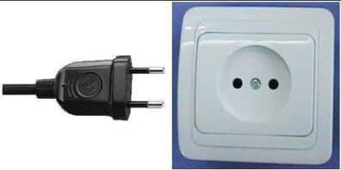

OPENING HOURS

- Public Administration Offices: Open: Monday to Friday (excluding public holidays) between 8:00 a.m. and 5:30 p.m.
- Banks: Open: Monday to Friday between 8 a.m. and 3:30 p.m. (excluding public holidays) and some banks open Saturday between 8 a.m. and 12 p.m.

CULTURE, RELIGION AND LANGUAGES

The Democratic Republic of Congo is made up of several ethnic groups who speak over 400 different languages. The official language is French. The Law recognises four national languages: Lingala, Swahili, Kikongo and Tshiluba. The Congolese population is predominantly Christian, divided between Catholics, Protestants and Kimbanguists. Islam is the second-largest religion.

HEALTH

The city is served by four major hospitals and several large private clinics. Visitors are advised to check with their health insurance providers to confirm whether their health insurance policies cover their needs in the DRC.

NB: In effect, a medical facility will be set up on the event site.

Yellow Fever Vaccination Certificate

To comply with international health regulations, the DRC health services may require travellers to have a valid international vaccination certificate. Certificates are also required for travellers who have transited infected areas.

Travellers in the DRC will be responsible for any expenses incurred as a result of yellow fever inoculation.

These recommendations are based on those of the World Health Organisation (2003) and the Centre for Disease Control (2003).

INSURANCE

The delegates are personally responsible for their insurance, in the event of personal injury, of medical emergency and loss of luggage and currencies.

RECEPTION AND REGISTRATION

Reception will be open at the entrance to Kin Plazza Arjaan Rotana Hotel.

TECHNICAL SECRETARIAT OF THE 25th ORDINARY SESSION OF THE ADMINISTRATIVE COUNCIL (AC) OF THE AFRICAN TELECOMMUNICATIONS UNION (ATU)

All participants are required to register by returning the completed registration form to the contacts below:

Ministry (Cabinet):

  - Mr Mike KONGOLO LUSANGA, Adviser to the Minister in charge of Monitoring Agreements with Technical Partners, Governance and Regulation.

Phone: +243 81,264 25 57; e-mail: mike.kongolo@ptntic.gouv.cd

  - Mr Léon TEGANYI, Financial Adviser
Phone: +243 82 18 52,105; e-mail: leon.teganyi@ptntic.gouv.cd

Mr Florent MUSUASUA MUTEBA, Adviser in Telecommunication and ICT
Phone: +243 81 20 93,333, e-mail: @ptntic.gouv.cdflorent.muteba

Service Provider:

  - Mr Alain MUMBA, General Manager, Unlimited Sarl RDC
Phone : +243 89 89 00 464, 99 55 75,153,

E-mail: alainmumba@unlimitedrdc.com

- MISCELLANEOUS SERVICES

- Services;
- Bank/Exchange office;
- Travel agency;
- Telecommunication services (Internet service, mobile phones).

WE WELCOME ALL DELEGATES TO KINSHASA AND WISH THEM A PLEASANT STAY DURING THIS GREAT CONTINENTAL EVENT!!!

